Appendix 1: Validations since March.2017

Error Number | Error Message | Reject Record | Description | Remediation
382 | If the Clinical Trial Enrolment Flag is Yes, a Clinical Trial Number must be provided. | Y | If (Clinical_trial_enrolment_flag is yes and the Clinical_trial_number field is missing), reject the record and issue the error message | Provide a clinical trial number
498 | Warning: scans are only reimbursed for Clinical Trial patients. | N | If Facility_Managing_Patient is null and Clinical_Trial_Enrollment_Flag is No and Nuclear_Medicine_Scan_Date is not null, accept the record and issue the warning message. | Scans are only reimbursed for Clinical Trial patients
501 | Error: Apparent duplicate records | Y | If record is for a scan (NUCLR_MED_SCAN_DATE is not null), reject submission with error if there are records where the following fields are the same: HEALTH_CARD_NUMBER, SUBMISSION_ORG_KEY, NUCLR_MED_SCAN_DATE, NUCLR_MED_SCAN_TYPE_KEY | Remove duplicate records
501 | Error: Apparent duplicate records | Y | If record is for a treatment (RADIONUCLID_THERAPY_DATE is not null), reject submission with error if there are records where the following fields are the same: HEALTH_CARD_NUMBER, SUBMISSION_ORG_KEY, RADIONUCLIDE_THERAPY_DATE, RADIO_ISOTOPE | Remove duplicate records
501 | Error: Apparent duplicate records | Y | If record is for both a scan and treatment, reject submission with if there are records where the following fields are the same: HEALTH_CARD_NUMBER, SUBMISSION_ORG_KEY, NUCLR_MED_SCAN_DATE, NUCLR_MED_SCAN_TYPE_KEY OR HEALTH_CARD_NUMBER, SUBMISSION_ORG_KEY, RADIONUCLIDE_THERAPY_DATE, RADIO_ISOTOPE | Remove duplicate records
629 | Facility Managing Patient is incorrect. Please refer to the Facility Number List | Y | If Facility_Managing_Patient is not null and Facility_Managing_Patient is not in the pre-defined list of values, reject the record and issue error message | Select a valid facility_managing_patinet
632 | "When radio isotope is entered, pharmaceutical dose is mandatory" | Y | If radio_isotope is not null and pharmaceutical_dose is null, reject record and display error msg. | Put in a pharmaceutical dose
633 | "When radio nuclide therapy date is entered, radio isotope is mandatory" | Y | If radio_nuclide_therapy_date is not null and radio_isotope is null, reject record and display error msg. | Put in a radio_isotope
634 | "When radio isotope is entered, dose unit is mandatory" | Y | If radio_isotope is not null and dose_unit is null, reject record and display error msg. | Put in a dose unit
635 | "When radio isotope is entered, radio nuclide therapy date is mandatory" | Y | If radio_isotope is not null and radio_nuclide_therapy_date is null, reject record and display error msg. | Put in a radio_nuclide_therapy_date
636 | Facility_Managing_Patient must have a value if Clinical trial number is NCT02743741 and nuclear medicine scan date is entered | Y | If (Nuclear Medicine Scan Date is provided and Clinical Trial Number is NCT02743741 and Facility Managing Patient is missing), reject the record and issue the error message. | Select facility_managing_patient
637 | If a clinical trial number is provided, the Clinical Trial Enrolment Flag must be Yes. | Y | If (Clinical_Trial_Number is a valid clinical trial value and the Clinical Trial Enrolment flag is No), reject the record and issue the error message. | Change clinical trial enrolment to yes OR remove clinical_trial_number
638 | Invalid clinical trial number - consult lookup table in template | Y | If an entry outside of the allowed trial numbers is made, display error message | Select a valid clinical trial number
639 | The field Clinical_trial_enrolment_flag is mandatory | Y | The field Clinical_trial_enrolment_flag is mandatory (always). | Fill in the clinical_trial_enrolment_flag column
670 | Pharmaceutical dose must be a positive number | Y | IF RADIOISOTOPE_DOSE is not null AND RADIOISOTOPE_DOSE < or = 0  THEN RAISE New Error 670 | Input a positive pharmaceutical dose

Appendix 2: Facility Numbers
# | Program Title | Submitting Hospital | Facility Number
4 | Neuroendocrine | London Health Sciences | 936
 |  | Hamilton Health Sciences Corporation | 942
 |  | University Health Network | 947
 |  | Sunnybrook Health Sciences Centre | 953

Appendix 3: Valid 2-digits Postal Codes
(Source: Cancer Care Ontario's Data Book - 2012-2013, Appendix B - Province and State codes, at link https://www.cancercare.on.ca/ext/databook/db1213/databook.htm).

The table below provides list of valid 2 digit postal codes for province and State codes.
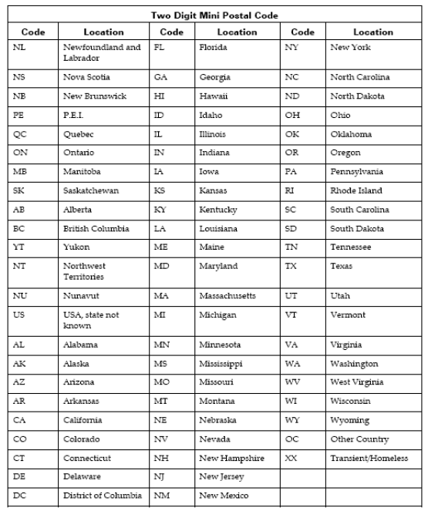

Appendix 4: Morphology Codes
This is a complete listing of valid Morphology codes and includes the new Haematopoietic codes effective January 2010.
Citation for new classification:
WHO Classification of Tumours of Haematopoietic and Lymphoid Tissues, 4th ed., edited by S. H. Swerdlow, et al., International Agency for Research on Cancer, Lyon, 2008. ISBN 978-92-832-2431-0
(For details, please refer Cancer Care Ontario's Data Book - 2012-2013, Appendix 1.36 - Morphology Codes, at link https://www.cancercare.on.ca/ext/databook/db1213/databook.htm)

Appendix 5: ICDO-3 Topography with Laterality
This is a table of topography codes where laterality is applied as stipulated in the FORDS manual.
(For details, please refer Cancer Care Ontario's Data Book - 2012-2013, Appendix 1.3 ICDO-3 TOPOGRAPHY with Laterality, at link https://www.cancercare.on.ca/ext/databook/db1213/databook.htm)

Appendix 6: Pharmaceutical dose unit
This table provides info for Radio pharmaceutical dose unit

Unit Code | Description
cap | capsule
MBq | megabecquerels
mcg | microgram
mEq | milliequivalent
MU | million units
tab | tablet
unit | unit
mg | milligram
mL | milliliter
drop | drop
pfu | plaque forming unit
cm | centimeter
g | gram
loz | lozenge
mmol | millimoles
part | particle
ptch | patch
pkt | packet
pop | popsicle
puff | puff
supp | suppository
mCi | millicurie

Appendix 7: Clinical Trial Numbers

172567
NCT02743741

Appendix 8: Facility Managing Patient

Facility Number | Facility Name
936 | London Health Sciences
942 | Hamilton Health Sciences Corporation
947 | University Health Network
953 | Sunnybrook Health Sciences Centre

Corresponds to appendix 3 on ALR
Corresponds to appendix 11 on ALR
Corresponds to appendix 20 on ALR
Corresponds to appendix 21 on ALR
Corresponds to appendix 22 on ALR

